Suite 34, 5 Liberty Square, Kings Hill,
West Malling, ME19 4AU
Phone: 0333-200-1595 Email: info@sharesoc.org
Web: www.sharesoc.org
UK Individual Shareholders Society

ShareSoc

FRC Investor Event on 3rd December 2018

This was a very well attended, very successful event held at the FRC office at 125 London Wall.
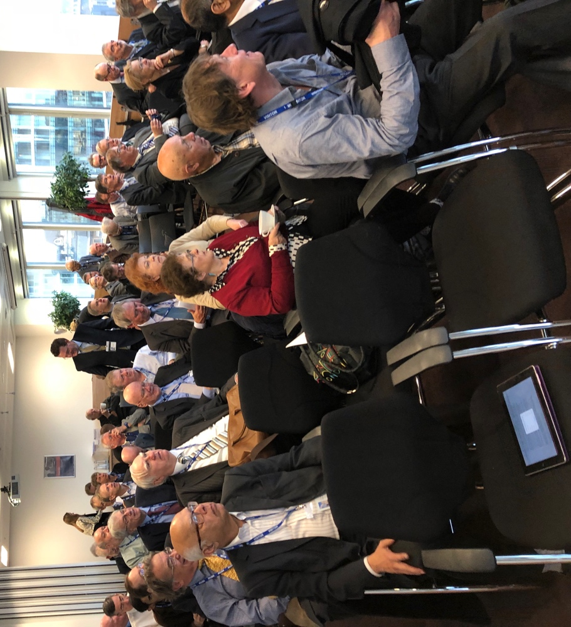
An attentive audience of over 70 UKSA and ShareSoc members listened to Senior members of the FRC team: Tracy Vegro (below), Jen Sisson, Carol Page, Andrew Meek, James Ferris, David Johnson, Claudia Mortimer, Catherine Horton, Marian Williams, Phil Fitzgerald and Deepa Raval.
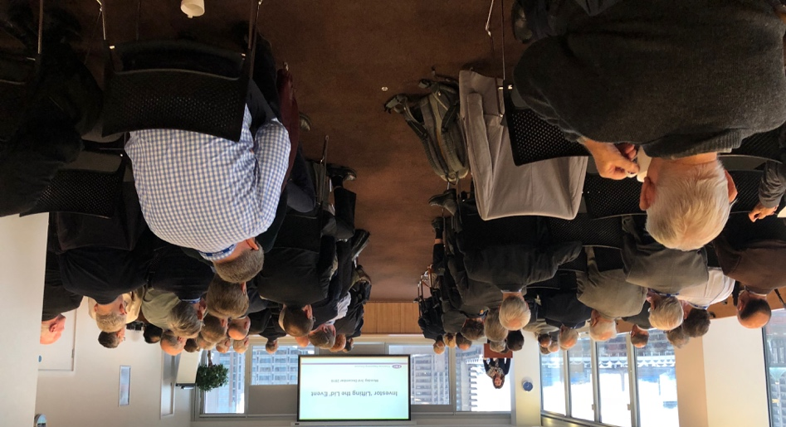
The FRC and the audit profession are being pilloried and heavily criticised. So, this was a chance for them to explain what they do and how well they are doing it. My verdict - they did a good job. We are very pleased that the FRC wishes to engage with individual investors and takes considerable time and effort to stage which has now become an annual event. This was the second and the FRC want to do another one next year. Demand from our side is high, so we will do another one. Thanks, in particular should go to Peter Parry who has worked hard to get to know the key people in the FRC and make this event happen.

FRC enforcement is on a growth curve, with fines up 20 fold from £1m in 2012 to £24m this year. (Note to FRC: you have a revenue recognition problem as you offer up to 35% discounts for early settlement, so the cash generated is not £24m!!!)
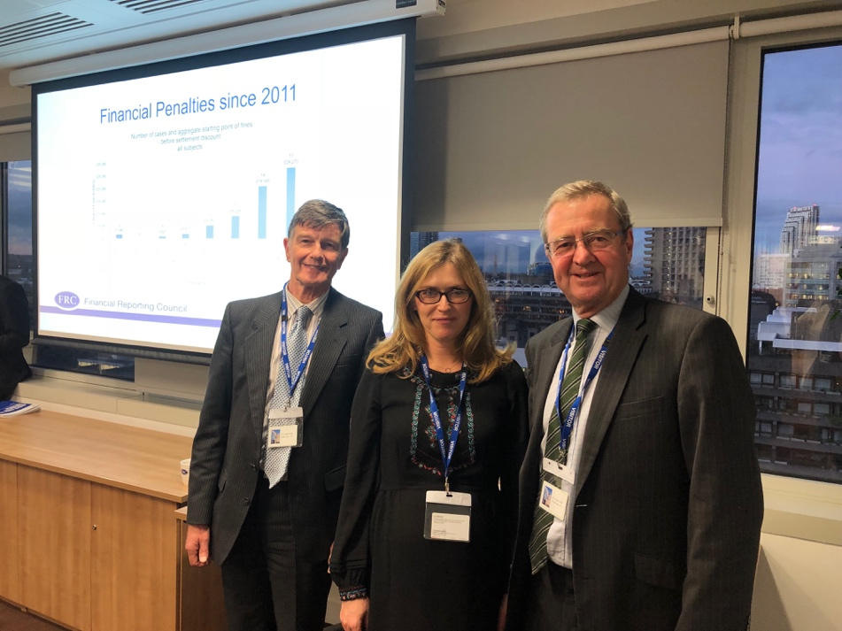

The FRC is more than just enforcement. It tries to stimulate best practice via the FRC Labs and the AQR (Audit Quality Review) does 220 reviews a year and rates audits on a 1, 2a, 2b and 3 scale. The FRC tells the company it rating and gives it a copy of its report, but does not publicise the reports to shareholders. Tip for an AGM question. Ask the Audit Chairman what the last AQR rating was and what issues were raised and what they have done about it.

The FRC sets the standards for the first half of the annual report, the strategic report, but does not set the accounting standards, which are set by the IASB, The International Accounting Standards. Much of our criticism of accounts is of the accounting standards (see the articles by Malcolm Howard and John Hunter in last month’s ShareSoc newsletter), which is outside the scope of the FRC. However, one of the attendees at the meeting was the delightful Aleksandra Maczynska, BETTER FINANCE’s Executive Director, (Picture above with Peter Parry and me) who agreed to raise with the IASB our concerns (fair value, intangibles, the speed at which companies with unqualified audits and supposedly good balance sheets go bust, e.g. Carillion, Conviviality). Working with our friends in Europe will be more effective than simply lobbying from the UK.

The FRC has come a long way since the dire days of 2006. We all await with interest the Kingman report. Our view is that the FRC should not be taken over by another body, the FRC needs more resources, its Board needs to be refreshed and made independent (too many auditors and accountants have too much power in the FRC Board) and it needs to be more open, transparent and act quicker. But these are leadership issues. The meeting attendees went away with the view that down at the coal face the FRC is doing good solid work, well at least that is my view!

Copies of the slide presentations will be made available in due course.

Cliff Weight
ShareSoc Director

4th December 2018

